Korea Aerospace Research Institute  Lunar Exploration Program Office  169-84 Gwahak-ro, Yuseong-gu, Daejeon 34133  Republic of Korea | ETRI  DTN Program Office  218 Gajeongno, Yuseong-gu, Daejeon 34129  Republic of Korea | 
 | Lumir Inc.  DTN Development Office  A-1102,767 Sinsu-ro, Yongin, Gyunggi, KOREA | 


Korea Lunar Exploration Program
DTN
Reliability Prediction for SBC
Date: 11 Mar. 2020 | Doc. No: KPLO-D1-554-028
 | Issue: F1.1
 | Total page: 12

Superseding F1.0

 |  | Prepared By:
 |  | Seong-Woon Cho DATE
 |  | DTN SBC Product Assurance
Reviewed By:
Dae-Soo Oh DATE
DTN SBC Project Manager
Approval Signature:
Cheol-Oh Jeong DATE |  | Jin-Ho Jo DATE
ETRI, DTN Product Assurance |  | ETRI, DTN System Engineer
Byoung-Sun Lee DATE
ETRI, DTN Program Manager

Original CDMO Release ____________________

REVISION / CHANGE RECORD

Revision | DOCUMENT DATE | REVISION / CHANGE DESCRIPTION | PAGES AFFECTED
D00 | 2016. 10. 07 | Draft | All
P00 | 2016. 11. 23 | Reliability Prediction Results Updated | 13
P01 | 2017. 11. 27 | Doc Number & Form Change | All
F1.0 | 2018. 10. 15 | Reliability Prediction Results & Data Updated | 13
F1.1 | 2020.03.11 | Update Reliability Prediction Result  Add Reliability Block Diagram  Add Appendix | 5 - 12

Table of Contents

1. INTRODUCTION ４
1.1 SCOPE ４
1.2 DTN OVERVIEW ４
2. DOCUMENTS ４
2.1 APPLICABLE DOCUMENTS ４
2.2 REFERENCE DOCUMENTS ４
3. ACRONYMS AND ABBREVIATIONS ５
4. Reliability Prediction ６
4.1 RELIABILITY MODELING ６
4.1.1 ASSUMPTIONS ６
4.1.2 ANALYSIS CONDITION ６
4.1.3 CALCULATIONS OF FAILURE RATES FOR PARTS ７
4.1.4 CALCULATIONS OF FAILURE RATES FOR SYSTEM ８
4.1.5 RELIABILITY BLOCK DIAGRAM ８
4.2 RELIABILITY ANALYSIS RESULT ９
5. Appendix １０
5.1 RELIABILITY PREDICTION BY MISSION TIME １０
5.2 RELIABILITY PREDICTION BY EEE PARTS １２

Figures

Figure 4-1 Configuration ６
Figure 4-2 Reliability block diagram ８
Figure 4-3 Reliability prediction result ９
Figure 5-1 Reliability prediction result by mission time 1 month １０
Figure 5-2 Reliability prediction result by mission time 2 months １０
Figure 5-3 Reliability prediction result by mission time 2 years １０
Figure 5-4 Reliability prediction result by mission time 3 years １１
Figure 5-5 Reliability prediction result by mission time 4 years １１
Figure 5-6 Reliability prediction result by mission time 7 years １１
Figure 5-7 Reliability prediction result by EEE parts １２

INTRODUCTION

SCOPE
This document summarizes Reliability Prediction for the Single Board Computer (SBC) to be developed for the DTN analysis procedures and documentation shall be performed in accordance with MIL-HDBK-217.

DTN OVERVIEW
The mission of DTN is to validate DTN communication protocols by space-link testing through KPLO. So DTN operations are focused on testing the DTN protocols using KPLO space-links.

DOCUMENTS

APPLICABLE DOCUMENTS
 | Document No. | Title
AD-1 | KPLO-D0-210-003 | User Requirements Document (KARI)
AD-2 | KPLO-D0-524-008 | User Requirements Document (ETRI)

REFERENCE DOCUMENTS
 | Document No. | Title
RD-1 | MIL-STD-461E | Requirements for the Control of Electromagnetic Interference Characteristics of Subsystems and Equipment
RD-2 | MIL-STD-462D | Measurements of Electromagnetic Interference Characteristics
RD-3 | ECSS-E-ST-10-06C | Space engineering Technical Requirements specification
RD-4 | ECSS-Q-60-11A | Derating and End of Life parameter drifts-EEE Components
RD-5 | MIL-HDBK-217 | Reliability Prediction for Electronic Equipment

ACRONYMS AND ABBREVIATIONS
AMS | Asynchronous Message Service
AOS | Advanced Orbiting System
BP | Bundle Protocol
BSS | Bundle Streaming Service
CCSDS | Consultative Committee for Space Data Systems
CFDP | CCSDS File Delivery Protocol
DCC | DTN Control Center
DTN | Delay(Disruption) Tolerant Network
DTNPL | DTN Payload
IP | Internet Protocol
KPLO | Korea Pathfinder Lunar Orbiter
LCM | Lander Communication Model
LTP | Liklider Transmission Protocol
M&C | Monitor & Control
RCM | Rover Communication Model
SLE | Space Link Extension
TBC | To Be Confirmed
TBD | To Be Defined
TCP | Transmission Control Protocol
UDP | User Datagram Protocol

Reliability Prediction

The Configuration of SBC (Single Board Computer) is shown as below (Figure 4-1) 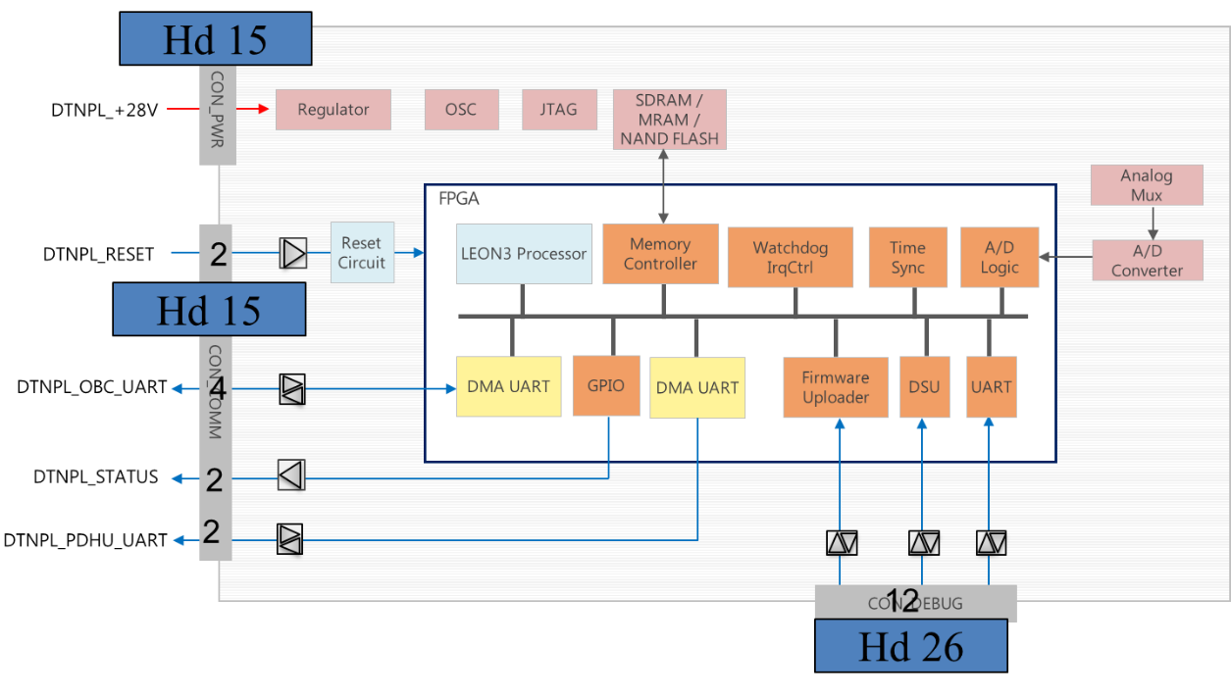
Figure 4-1 Configuration

RELIABILITY MODELING
A reliability prediction is one of the most common forms of reliability analysis, and an important element in the process of selecting electronic equipment.
The purpose of reliability prediction is to estimate the inherent reliability of electronic equipment and systems. Thus engineers can compare and evaluate reliability predictions of related or competitive designs.
As used here, reliability is a measure of the frequency of equipment failures as a function of time. The equipment(or system) failure rate is calculated using failure rates of parts and assemblies(or units). These predictions can help development engineers make decisions about component selection, stress levels and different designs.

ASSUMPTIONS
- The increased risk of failure during the early life can be disregarded.
- The wear-out period is never reached.

ANALYSIS CONDITION
- Calculation Method : MIL-HDBK-217F Notice 2
- Environment : Space Flight
- Operating Temperature : 50 °C
- Duty cycle : 100%
- Mission Time : 8,760hours (1 year)

CALCULATIONS OF FAILURE RATES FOR PARTS
- Microcircuit, gate/logic arrays and microprocessors
-
- Microcircuit, memories
-
- Diodes, low frequency
-
- Diodes, high frequency
-
- Diodes, low frequency, bipolar
-
- Transistors, low frequency, bipolar
-
- Transistors, low frequency, Si FET
-
- Transistors, high frequency, Si FET
-
- Transistors, high frequency, GaAs FET
-
- Optoelectronics, detectors, isolators, emitters
-
- Resistors
-
- Capacitors
-
- Inductive Devices, Transformers, Coils
-
- Connectors, general
-
- Relay, mechanical
-
- Relay, solid state and time delay
-
- Switches
-
- Quartz crystals
-
- Fuses
-

CALCULATIONS OF FAILURE RATES FOR SYSTEM
- 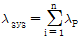

RELIABILITY BLOCK DIAGRAM

SBC

Figure 4-2 Reliability block diagram

RELIABILITY ANALYSIS RESULT

The SBC reliability prediction result is show Table 4-1

Value | Result
Duty Cycle | 100%
Failure Rate [FIT] | 2,706.725
MTBF [Hours] | 369,450
Reliability | 0.9766
Table 4-1 Reliability prediction result

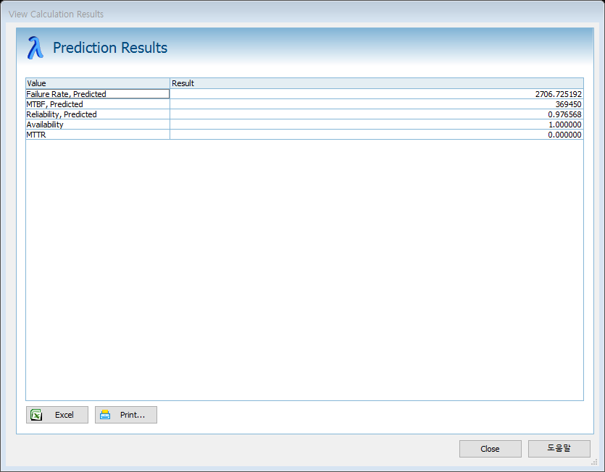
Figure 4-3 Reliability prediction result (@Windchill Quality Solutions 11.0)

SBC reliability Prediction result is complied with allocated requirement.

Appendix

RELIABILITY PREDICTION BY MISSION TIME
 | 1 month | 2 months | 1 year | 2 years | 3 years | 4 years | 7 years
Hours | 720 | 1,440 | 8,760 | 17,520 | 26,280 | 35,040 | 61,320
Reliability | 0.9980 | 0.9961 | 0.9766 | 0.9537 | 0.9313 | 0.9095 | 0.8470
Table 5-1 Reliability prediction result by mission time

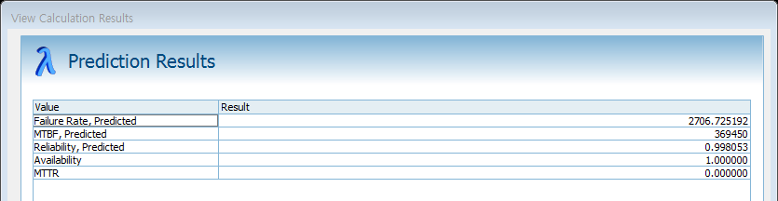
Figure 5-1 Reliability prediction result by mission time 1 month

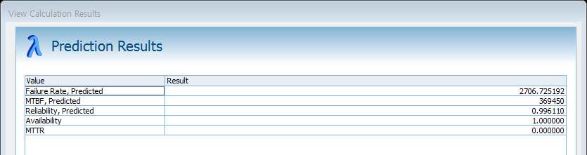
Figure 5-2 Reliability prediction result by mission time 2 months

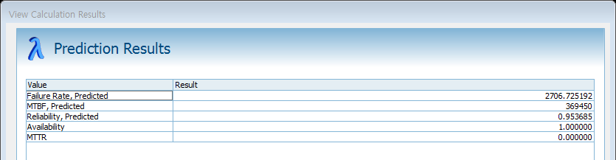
Figure 5-3 Reliability prediction result by mission time 2 years

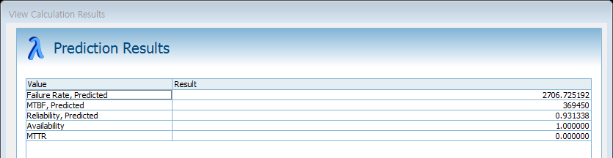
Figure 5-4 Reliability prediction result by mission time 3 years

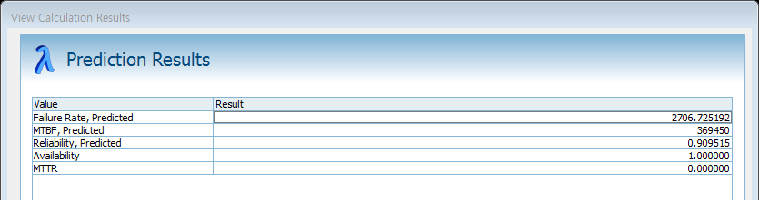
Figure 5-5 Reliability prediction result by mission time 4 years

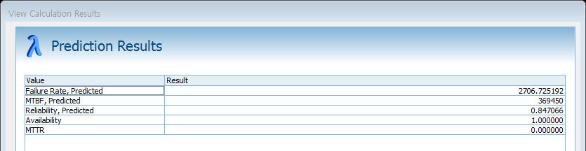
Figure 5-6 Reliability prediction result by mission time 7 years

RELIABILITY PREDICTION BY EEE PARTS
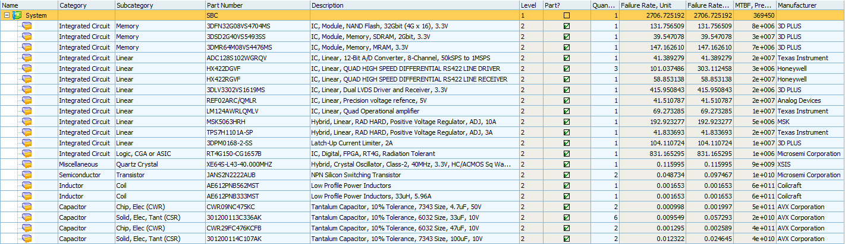
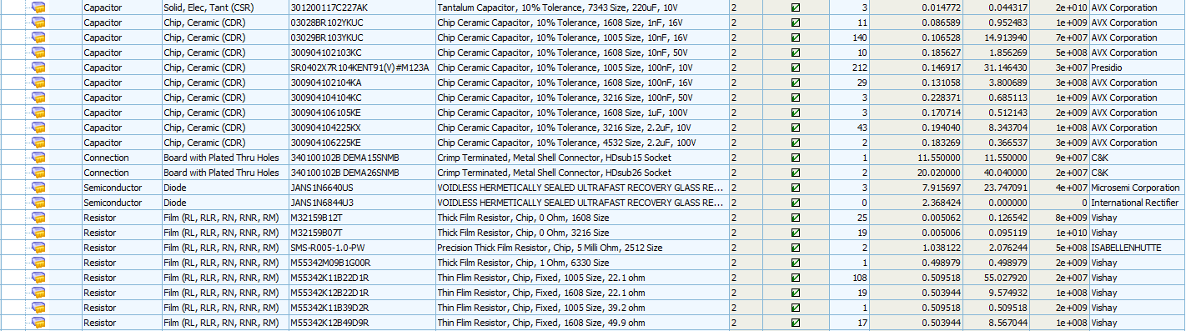
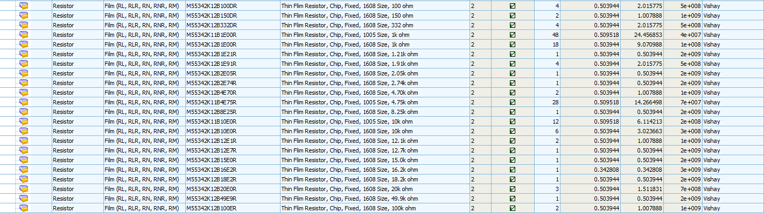
Figure 5-7 Reliability prediction result by EEE parts

